
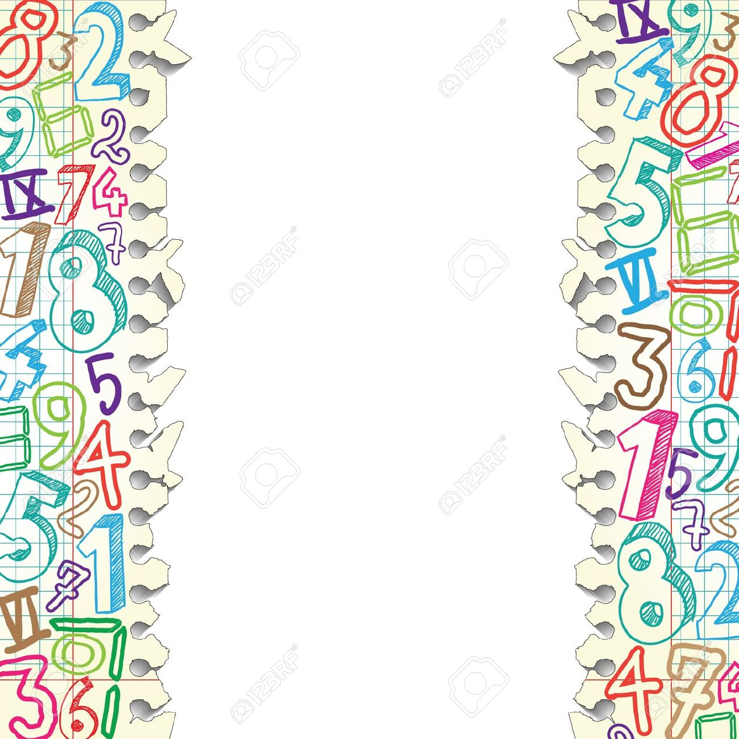
- What I heard you say was…
- How did you know…?
- Explain why/how…?
- Why is _____ important?
- I agree/disagree because…
- How else could you solve it?
- What are you thinking now?
- What would happen if…?
- I agree/disagree with _____ because….
- Can you explain more?
- What evidence supports your answer?
- What key words helped you solve this?
- How is this like other problems you’ve solved?
- Did anyone think of this in a different way?
- Is there any other way to start the problem?
- Please explain how you know your answer is right.

Math Talk

- What is another way to look at….?
- How could ______ be used to ____?
- My strategy is like yours because…
- What will you do next?
- Was that the first strategy you tried?
- Why did you choose that strategy?
- Describe _____ in your own words.
- Please explain the steps you used.
- How did this help you understand?
- How does ______ affect _____?
- What did you start with?
- Why did you think that?
- What strategy did you use?
- How did you solve it?
- Please tell me more about _____.
- What made you decide to do this?
- What is the difference between…?
- That is a good answer because…
- I got different results because…
- What is another example of…?
- Why did you use that operation?

